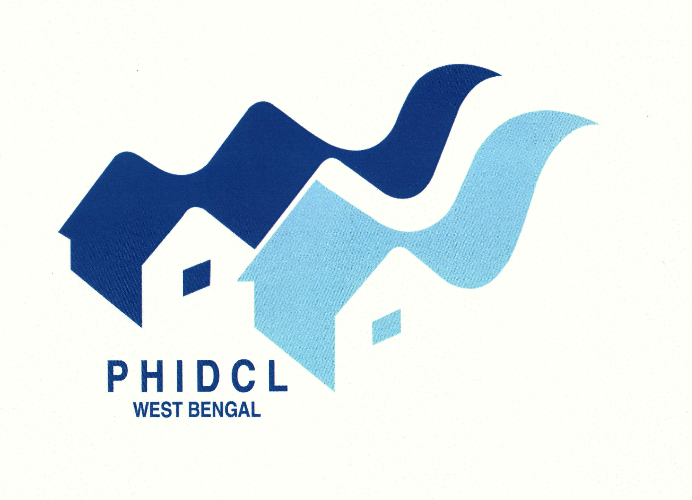 | West Bengal Police Housing and Infrastructure Development Corporation Limited  CIN NO: U70109WB1993SGC058358  GSTIN: 19AAACW6099C2Z1  Araksha Bhawan, 3rd Floor, Block – DJ, Sector – II,  Salt Lake City, Kolkata – 700091.  Ph. & FAX . 033 – 23586188, E-mail : tenderofhousing@gmail.com

Memo No. ENGG/ADVT./1533/2016/528 Date: 13.11.2020
To
The Advertising Manager
Eisamay
12 th floor 8, Shantiniketan Building
Camac Street, Kolkata 700017

Sir,
You are requested to publish the following matter in your news paper on 14.11.2020 in black and white
Format, measuring minimum (h) X 8 cm. (w). The payment will be made by Chairman & Managing Director, West Bengal Police Housing &amp; Infrastructure Development Corpn. Ltd., Araksha Bhawan, 3 rd Floor, Block DJ, Sector II, Salt Lake City, Kolkata 700 091 after submitting the bill in triplicate form .
However, the bill for the advertisement should be as per the Gov’t norms.

NOTICE INVITING OFFLINE TENDER – A) WBPHIDCL/EE(HQ-I)/NIT- 103/2020-2021 (2nd Call), WB Police Housing & Infrastructure Development Corpn Ltd having its office at 3rd floor, Araksha Bhawan, Block – DJ, Sector – II, Salt Lake, Kolkata – 91 is inviting open Offline Tender from experienced agency for works of A) i) AMC of Air Conditioner for the work of annual Repair & Maintenance for the year 2020-21 of IPS Mess at Alipore, South 24- Parganas up to 31/03/2021. Estimated Amount put to Tender Rs. 64,820/-, Last date & time of submission of bids offline is 27.11.2020 at 12 PM. For further details please visit www.wbphidcl.com and see office notice board.

Yours’ faithfully,

SD/-
Executive Engineer (HQ-I),
WBPHIDCL

